BENEFITFOCUS App User Guide
Installing the Benefitfocus App
- Using your mobile device, navigate to the Google Play store for Android users or the App Store for Apple users.

- Search for the Benefitfocus App.
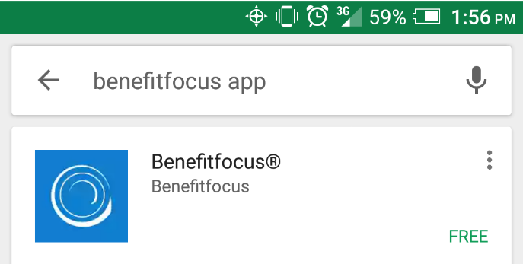
- Select to download and install the app.
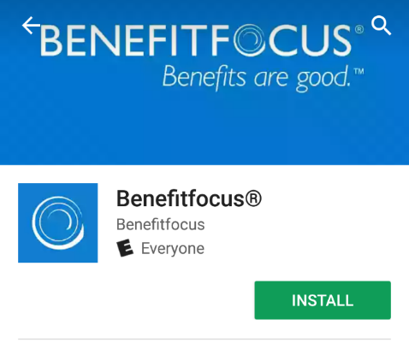
- Tap the icon and open the App after it has done installing
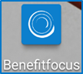

- First time only) Read the terms of service and tap Accept Terms of Use if you agree to the terms of service. (You must agree to the terms of use to continue.)
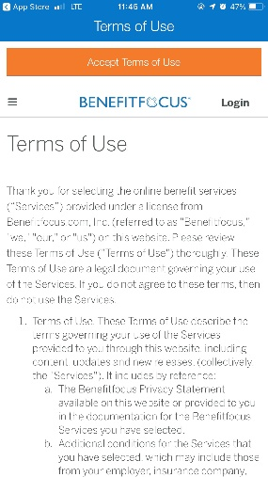
- (First time only) Enter your Company ID and tap next. Company ID is SHP.
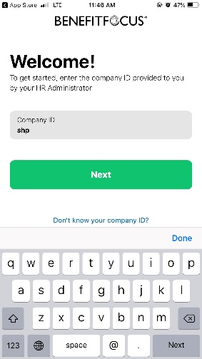
- You have successfully downloaded the app!
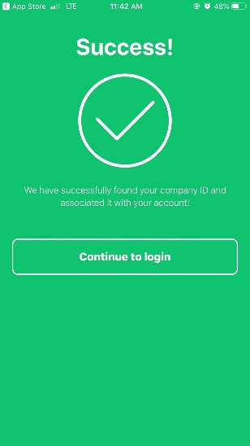
Uploading and submitting Dependent Verification Documents
- Click to open the Benefitfocus App.

- Click on SHP_NC State to sign in using your MyPack Portal credentials.

- Sign in using your Unity ID and Password

- Tap approve to complete the Duo Mobile verification.
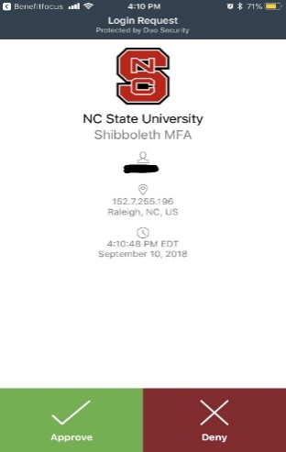

- Tap accept to allow to access the service

- Click on ‘Account’ located on the bottom of the BenefitFocus panel.

- Click on ‘Documents’ from the Manage Account list.
- To add a new document, click ‘Add New Document’.
- Tap the plus icon on the center of the page this allows you to take a new picture or to select an existing imagine from your device.
- Tap and enter a descriptive name for the document in the ‘Document Name’ field.
- Select a category for the document.
- Associate the document with a specific dependent.
- Last step is to SAVE your document!

